DEVELOP A MOBILE APPLICATION

|  |  |
| --- | --- |
| Date | 16 November 2022 |
| Project Name | Smart farmer-IOT enabled smart Farming Application |

Step:1 Login to MIT App Inventor

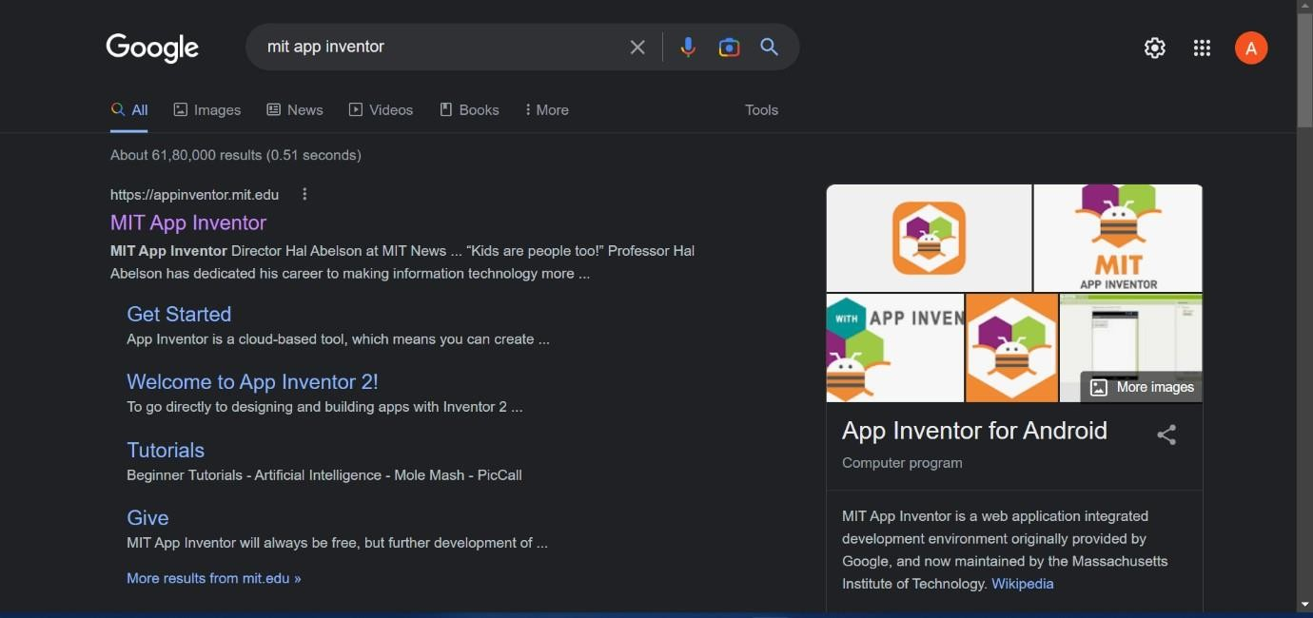

Step:2 Drop & place The Essential Features In The Front End Process

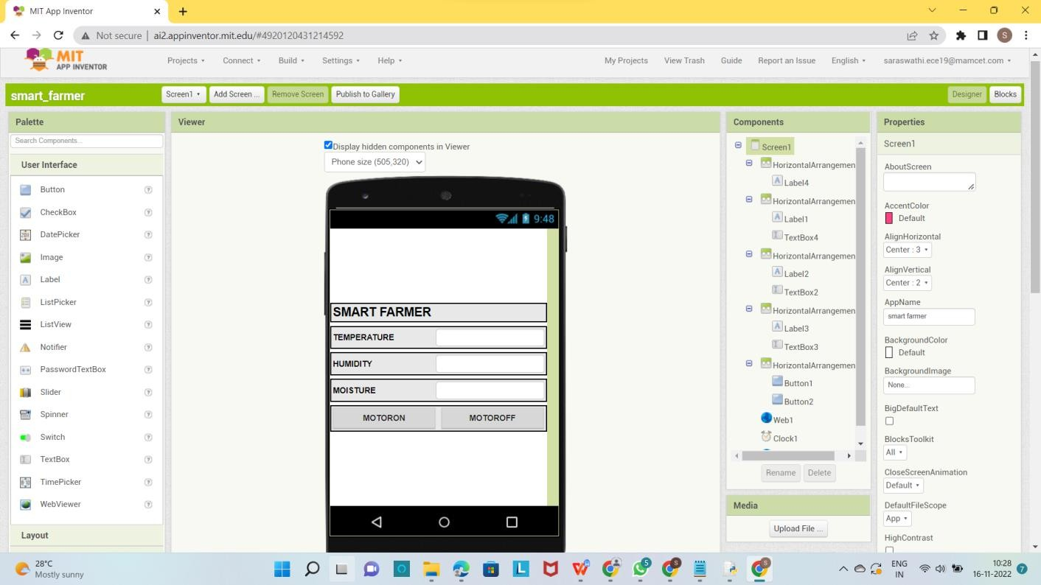

Step:3 Backend Block

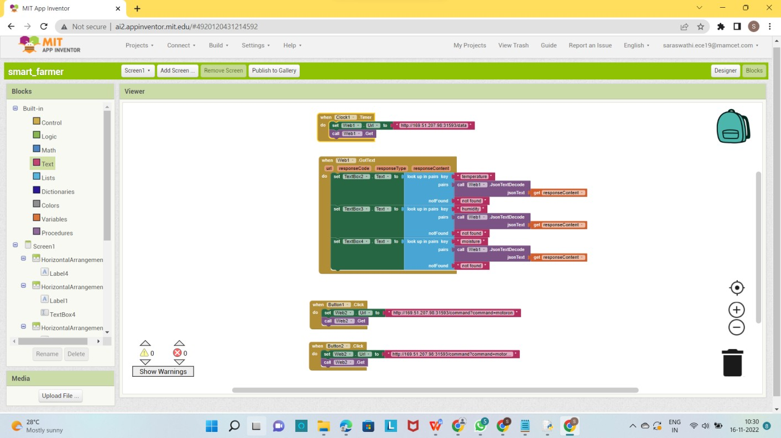

Step:4 Build the App & Install

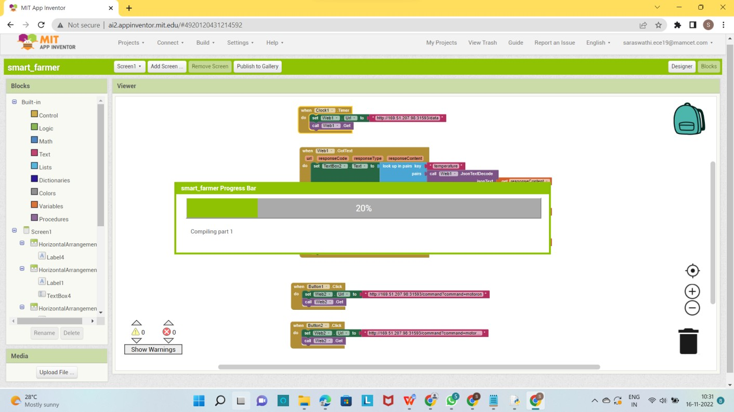

Step:5 Status or Output

